Frinika
Milestone 4 - Refactoring
Team member Student ID
Buthainah Aldosary 6302459
Jagdeep Singh 6449948
Luiz Mauricio Silva 6317006
Mischell Flor 5428483
Seun Odutola 6078109

TABLE OF CONTENTS

1. Implement a refactoring 2
1.1. Patchset 0/3: Description 2
1.2. Patchset 1/3: Remove Inner classes from ControllerView 2
1.3. Patchset 2/3: Group relevant methods and fields from ControllerView and its parent class ItemPanel 4
1.4. Patchset 3/3: Move method and field from the old class to new class 6

Implement a refactoring

Patchset 0/3: Description
Hash Code: e58c5f1dbbdfdd4b00a7500985a3732f86209205

Extract Classes will be implemented to split the responsibilities from a large class ControllerView. This class contains multiple methods with different responsibilities as well as inner classes
The first patch will remove the inner classes such as NoteOnScreenCollection and NoteOnScreenIterator from ControllerView and create java classes for them. See figure below before changes
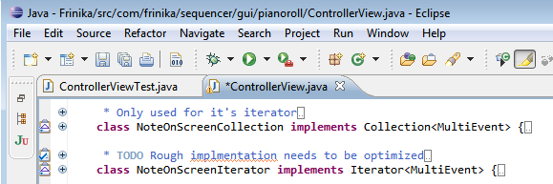

In the second patch, related methods will be grouped together and copied. Then the copied data will be placed to a new class.
In the last patch, Move Field and Move Method will be implemented. So all methods that are defined in the new class will be removed from the ControllerView.

Patchset 1/3: Remove Inner classes from ControllerView
Hash Code: 1234d58f04edbdd331e708a452dc1f926ad32144
Patch: 0001-For-Patch-1-Extract-Inner-classes-from-ControllerVie.patch

ControllerView is large class and highly coupled. Hence, it is hard to maintain and to reuse it. The inner classes that are found in the ControllerView are not being used anywhere in Frinika. Therefore, they are good candidate to be removed from ControllerView and the refactoring has none or very minimal impact in the system.
PatchSet Description
- New Classes are added in the module com.frinika.sequencer.gui.pianoroll
NoteOnScreenIterator.java
NoteOnScreenCollection.java
These classes are previously inner classes of ControllerView.
- Added New Unit Test: ControllerViewTest.java
The unit test checks newly added classes. It also checks if ControllerView got broken when inner classes are removed.
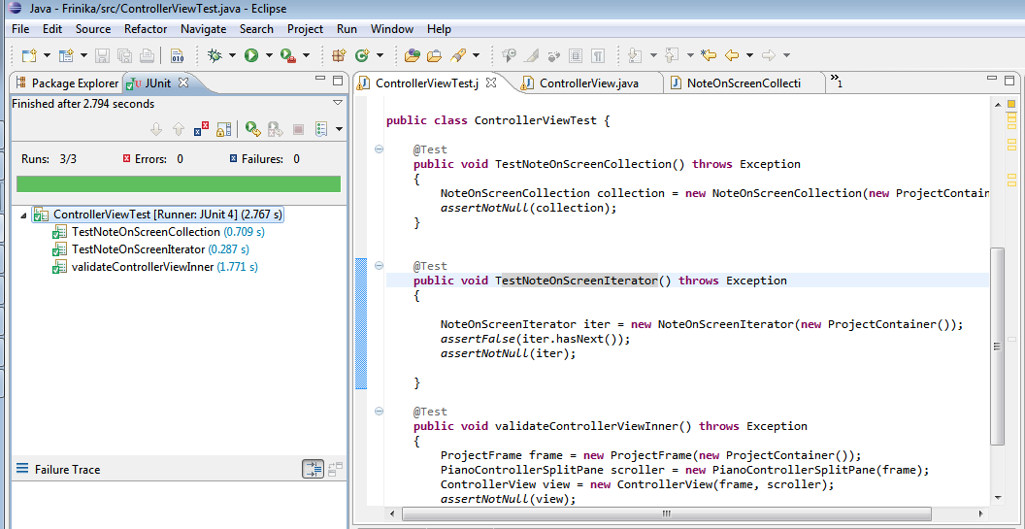

- Patch Diff
Patch 1 Diff
... | ... | @@ -964,141 +964,8 @@ public class ControllerView extends PianoRollPanelAdapter implements Adjustment
964 | 964 | project.getMultiEventSelection().notifyListeners();
965 | 965 | }
966 | 966
967 |  | - /**
968 |  | - * Only used for it's iterator
969 |  | - *
970 |  | - * @author pjl
971 |  | - *
972 |  | - */
973 |  | - class NoteOnScreenCollection implements Collection<MultiEvent> {
974 |  | -

....
1047 |  | - class NoteOnScreenIterator implements Iterator<MultiEvent> {
1048 |  | -
1049 |  | - Iterator<Part> partIter = null;
1050 |  | -
1051 |  | - Iterator<MultiEvent> noteIter = null;
1052 |  | -
1053 |  | - NoteOnScreenIterator() {
1054 |  | - partIter = project.getPartSelection().getSelected().iterator();
1055 |  | - advanceToNextMidiPart();
1056 |  | - }
1057 |  | -

The diff shows that NoteOnScreenCollection and NoteOnScreenIterator are removed from ControllerView

Patchset 2/3: Group relevant methods and fields from ControllerView and its parent class ItemPanel
Hash Code: 4db03d7b7e3e5e30b771604451ee07743996c031
Patch Name: 0001-For-Patch-2-Extract-class-by-grouping-relevant-metho.patch

ItemPanel class has multiple abstract methods that are scattered in the class. For separation of concern, it is good to group relevant methods. In this patch set, there are two new classes which are IClient and ClientRequests. The methods of IClient are copied from ItemPanel and the methods of ClientRequest are copied from ControllerView and from PianoRollPanelAdapter.

Note: ItemPanel is parent of PianoRollPanelAdapter and this class is a parent of ControllerView

The first diff shows the abstract methods that are copied from ItemPanel class
old | new
... | ... | @@ -0,0 +1,11 @@
 | 1 | +package com.frinika.sequencer.gui;
 | 2 | +
 | 3 | +
 | 4 | +public interface IClient {
 | 5 | +
 | 6 | + public abstract void clientAddToSelection(Item item);
 | 7 | + public abstract void clientRemoveFromSelection(Item item);
 | 8 | + public abstract void clientNotifySelectionChange();
 | 9 | + public abstract void clientClearSelection();
 | 10 | +
 | 11 | +}

The second diff shows the implementation of IClient
old | new
... | ... | @@ -0,0 +1,54 @@
 | 1 | +package com.frinika.sequencer.gui.pianoroll;
 | 2 | +
 | 3 | +import java.util.Vector;
 | 4 | +import com.frinika.project.ProjectContainer;
 | 5 | +import com.frinika.project.gui.ProjectFrame;
 | 6 | +import com.frinika.sequencer.gui.IClient;
 | 7 | +import com.frinika.sequencer.gui.Item;
 | 8 | +import com.frinika.sequencer.gui.ItemPanel;
 | 9 | +import com.frinika.sequencer.gui.ItemScrollPane;
 | 10 | +import com.frinika.sequencer.model.MultiEvent;
 | 11 | +
 | 12 | +abstract public class ClientRequest extends ItemPanel{
 | 13 | +
 | 14 | +
 | 15 | + private static final long serialVersionUID = 1L;
 | 16 | +
 | 17 | + Vector<MultiEvent> notesUnder;
 | 18 | +
 | 19 | + MultiEvent dragEvent;
 | 20 | +
 | 21 | +
 | 22 | + Iterable<MultiEvent> eventsInFocus;
 | 23 | + final ProjectContainer project;
 | 24 | +
 | 25 | + public ClientRequest(final ProjectContainer project, ItemScrollPane scroller,boolean hasTimeLine, boolean canScrollY, double d, boolean b) {
 | 26 | + super(project,scroller, hasTimeLine, canScrollY,.5,false);
 | 27 | + this.project = project;
 | 28 | + }
 | 29 | +
 | 30 | + @Override
 | 31 | + public void clientNotifySelectionChange() {
 | 32 | + this.project.getPartSelection().notifyListeners();
 | 33 | + }
 | 34 | +
 | 35 | + @Override
 | 36 | + public void clientAddToSelection(Item item) {
 | 37 | + project.getMultiEventSelection().addSelected((MultiEvent) item);
 | 38 | + project.getMultiEventSelection().notifyListeners();
 | 39 | + }
 | 40 | +
 | 41 | + @Override
 | 42 | + public void clientRemoveFromSelection(Item item) {
 | 43 | + project.getMultiEventSelection().removeSelected((MultiEvent) item);
 | 44 | + project.getMultiEventSelection().notifyListeners();
 | 45 | + }
 | 46 | +
 | 47 | + @Override
 | 48 | + public void clientClearSelection() {
 | 49 | + project.getMultiEventSelection().clearSelection();
 | 50 | + }
 | 51 | +
 | 52 | +}
 | 53 | +
 | 54 | +

Patchset 3/3: Move method and field from the old class to new class
Hash Code: e629f4de094d00cd2ee4b96b2be1e986f61ecc0e
Patch: 0001-Patch-3-Move-Methods-and-Move-Fields-from-the-old-cl.patch

The last patch uses Move method and Move field to properly transfer the methods and fields that belongs to a new class and are no longer in used from the old class. This is needed to avoid data redundancy and for the completion of extract class refactoring and for cleanup purposes.

As you can see in the diff , the extracted codes are now removed from the old class
961 | 949
962 |  | - @Override
963 |  | - public void clientAddToSelection(Item item) {
964 |  | - project.getMultiEventSelection().addSelected((MultiEvent) item);
965 |  | - project.getMultiEventSelection().notifyListeners();
966 |  | - }
967 | 950
968 |  | - @Override
969 |  | - public void clientRemoveFromSelection(Item item) {
970 |  | - project.getMultiEventSelection().removeSelected((MultiEvent) item);
971 |  | - project.getMultiEventSelection().notifyListeners();
972 |  | - }
 | 951 | +

